E10 Microwave

User Manual

Annie zhang (Z3459054) and stephen chung (Z3463108)

2016

# Copyright

Copyright © 2016 E10 Microwave

This user manual and the software system for the E10 Microwave are the intellectual property of the E10 Group and are protected under international copyright laws.

No part of the software code nor of this guide may be reproduced, distributed, translated, or transmitted in any form or by any means, electronic or mechanical, including photocopying, recording, or storing in any information storage and retrieval system, without the prior written permission of the E10 Group.

# Preface

The E10 Microwave software has been designed according to the COMP2121 specifications. The E10 Microwave uses the Arduino ATmega2560 chip set with a custom built AVR board supplied by the staff of COMP2121. The E10 Microwave software was written using Assembly. The E10 Microwave was designed to revolutionise the way food is heated and will change the world forever. This guide will allow the user to understand how to operate the E10 Microwave software. This guide is written for Windows users, users of other operating systems are to use their knowledge of equivalent instructions.

# Contents

Copyright 1

Preface 1

Contents 2

Getting started 3

Wiring the AVR Board 3

Connecting to the Computer 5

Find COM Port Number 5

Using the Program 5

Buttons 6

Display 6

LED 6

Basic Instructions 7

Entry Mode 7

Running Mode 7

Paused Mode 7

Finished Mode 7

Safety Information 8

Troubleshooting 8

Failure to download with ‘console.bat’ 8

Board not functioning 8

FAQ 9

Contact Information 9

# Getting started

The following figure is the microwave emulator AVR board.

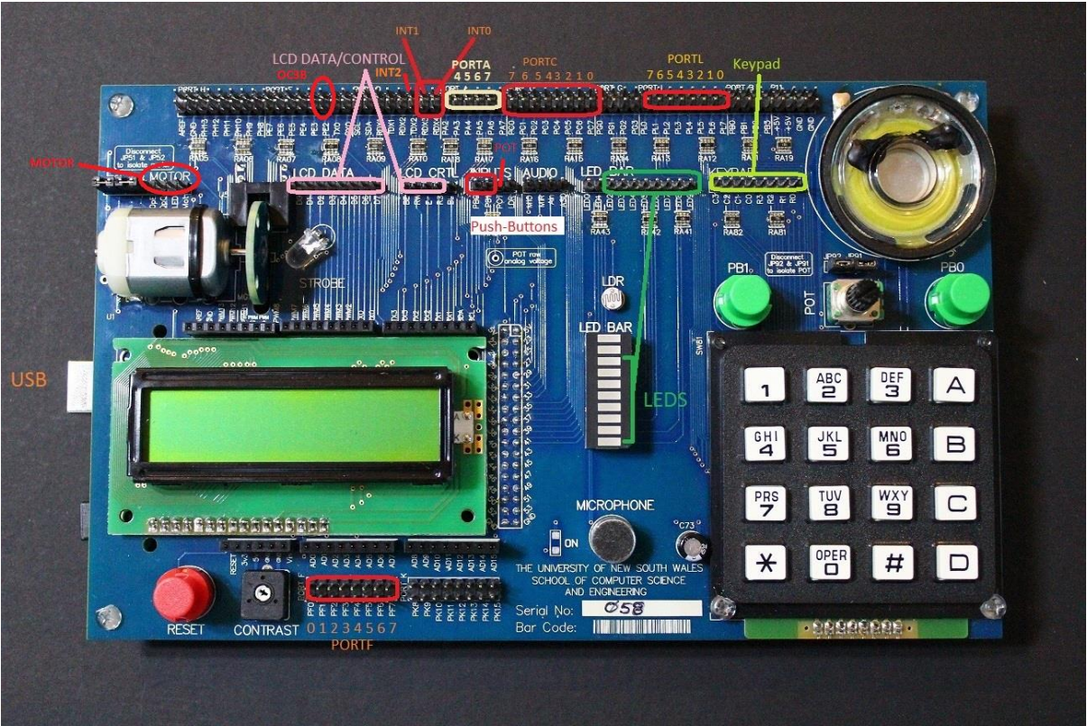

## Wiring the AVR Board

For the E10 Microwave to perform correctly, the following connections need to be made. These connections are described in terms of the labelling on the board.

|  |  |  |  |
| --- | --- | --- | --- |
| AVR Pins (top and bottom row) | | Input/Output Device Pins (middle row) | |
| Port Group | **Pin** | **Port Group** | **Pin** |
| PORT F | PF0 | LCD DATA | D0 |
| PORT F | PF1 | LCD DATA | D1 |
| PORT F | PF2 | LCD DATA | D2 |
| PORT F | PF3 | LCD DATA | D3 |
| PORT F | PF4 | LCD DATA | D4 |
| PORT F | PF5 | LCD DATA | D5 |
| PORT F | PF6 | LCD DATA | D6 |
| PORT F | PF7 | LCD DATA | D7 |
| PORT E | PE6 | MOTOR JUMPER | JP91 |
| PORT D | +5V | MOTOR | OpE |
| PORT D | OpO | MOTOR | TDX2 |
| PORT D | RDX3 | PUSH BUTTON | PB01 |
| PORT D | RDX4 | PUSH BUTTON | PB00 |
| PORT A | PA4 | LCD CTRL | BE |
| PORT A | PA5 | LCD CTRL | RW |
| PORT A | PA6 | LCD CTRL | E |
| PORT A | PA7 | LCD CTRL | RS |
| PORT C | PC0 | LED BAR | LED2 |
| PORT C | PC1 | LED BAR | LED3 |
| PORT C | PC2 | LED BAR | LED4 |
| PORT C | PC3 | LED BAR | LED5 |
| PORT C | PC4 | LED BAR | LED6 |
| PORT C | PC5 | LED BAR | LED7 |
| PORT C | PC6 | LED BAR | LED8 |
| PORT C | PC7 | LED BAR | LED9 |
| PORT G | PG2 | LED BAR | LED0 |
| PORT L | PL0 | KEYPAD | C3 |
| PORT L | PL1 | KEYPAD | C2 |
| PORT L | PL2 | KEYPAD | C1 |
| PORT L | PL3 | KEYPAD | C0 |
| PORT L | PL4 | KEYPAD | R3 |
| PORT L | PL5 | KEYPAD | R2 |
| PORT L | PL6 | KEYPAD | R1 |
| PORT L | PL7 | KEYPAD | R0 |
| PORT B | PB0 | SPEAKER | Red Wire |

## 

## Connecting to the Computer

To connect the board to the computer, use the USB Type-B port on the Arduino (left side). A green light should be visible on the Arduino board.

## Find COM Port Number

To work out which COM port the Arduino is connected to, open system properties by clicking the start button, right-clicking ‘My Computer’ then clicking properties. In the ‘Hardware’ tab, click ‘Device Manager’. You may get a warning about administrator privileges that you can ignore. Scroll down to ‘Ports (COM & LPT)’. There should be one item called ‘Arduino Mega 2560 (<portname>)’.

## Using the Program

Download the file ‘programmer.zip’ from the ‘AVR resources’ page on the COMP2121 website. Extract the files and open the folder. Run the batch file ‘console.bat’ to open up a command prompt. To load the microwave emulator program, run using the download command:

download <comport> <hexfile>

<comport> is the name of the port you found earlier in the previous section.

<hexfile> is the hex file for the microwave emulator.

If the download is successful, the command prompt will display a message indicating success.

## Buttons

|  |  |
| --- | --- |
| Button | Function |
| 0-9 | Digit input |
| A | Enter power selection in entry mode |
| C | Add 30 seconds in running mode |
| D | Subtract 30 seconds in running mode |
| * | Start button |
| # | Stop button |
| Left push button | Open the door |
| Right push button | Close the door |

## Display

|  |  |
| --- | --- |
| Display | Representation |
| 00:00 | Current time |
| ‘-‘, ‘\’, ‘|’, ‘`’ | Turntable |
| O or C | O for door open, C for door closed |

## LED

|  |  |
| --- | --- |
| LED Position | Representation |
| Top most LED | Door is open |
| Bottom 8 LEDs | Power level (2 for 25%, 4 for 50%, 8 for 100%) |

# 

# Basic Instructions

## Entry Mode

* Input up to four digits for desired cook time using the keypad buttons 0-9. If you do not have any preference for cook time, the default cook time is 1 minute. To clear the displayed time, press the stop button (#).
* Press A to set power level: 1 for 25%, 2 for 50% or 3 for 100%. Press stop button (#) to exit power selection. If you do not have any preference for power level, the default power level is 100%.
* To start cooking, press the start button (*) to enter running mode.
* If you accidentally open the door by pressing the left push button, press the right push button to close the door and resume entry mode.

## Running Mode

* Press C to add 30 seconds to the cooking time. Press D to subtract 30 seconds from the cook time. Press the start button (*) to add 1 minute to the cook time.
* If you wish to pause cooking, press the stop button (#) to enter pause mode.
* When the time reaches 00:00, cooking has finished and will enter finished mode.
* If you accidentally open the door by pressing the left push button, press the right push button to close the door and resume running mode.

## Paused Mode

* Press the start button (*) to resume cooking.
* Press the stop button (#) to return to entry mode.
* If you accidentally open the door by pressing the left push button, press the right push button to close the door and resume paused mode.

## Finished Mode

* When the food has finished cooking, the display will say “Done, Remove Food” and will beep three times.
* To remove food, open the door by pressing the left push button.
* Close the door by pressing the right push button to finish or continue back to entry mode.

# Safety Information

Do not be silly with the AVR board or your computer and you should not be able to kill yourself. The software will definitely not kill you.

# Troubleshooting

## Failure to download with ‘console.bat’

* Ensure your com port is correct
* Ensure you are downloading the correct hex file
* Ensure the hex file is in the correct directory, if not in the directory of ‘console.bat’ then navigate to the directory of the hex file through the command prompt
* Try editing the ‘download.bat’ file and replace:

"c:\Program Files\Arduino\hardware\tools\avr\bin\avrdude.exe" -C "c:\Program Files\Arduino\hardware\tools\avr\etc\avrdude.conf"

with:

"c:\Program Files (x86)\Arduino\hardware\tools\avr\bin\avrdude.exe" -C "c:\Program Files (x86)\Arduino\hardware\tools\avr\etc\avrdude.conf"

* Try installing the Arduino IDE.
* Otherwise, google it.

## Board not functioning

* Ensure the wiring is all connected properly, adjust potentiometer for motor
* Ensure the board is plugged to the computer via USB cable while operating the microwave
* Try downloading the microwave program again
* Try pressing the reset button
* If the motor is not spinning, ensure the PE2 jumper is removed
* There may be a fault with the AVR board. Please contact the COMP2121 staff for help.

# FAQ

**Q**: Why is my food not getting hot?

**A**: This is only an emulator. It is not a real microwave.

**Q**: This software is terrible!

**A**: We’re students, give us a break. Also, that is not a question.

**Q**: What do I do if I need to contact someone for help, to complain or to provide feedback?

**A**: Keep reading, the contact information is in the next section.

# Contact Information

|  |  |
| --- | --- |
| Contact | Contact Details |
| COMP2121: Staff | CSE Building (K17 of UNSW) |
| CEO of COMP2121: Daniel Murphy | dtsm460@cse.unsw.edu.au |
| E10 Group: Program Creators | CONFIDENTIAL |